To use the LDAP in our Pega Server

Softwares needed

PRPC Personal Edition

Download Java Latest Edition Used Java 11 version

Download Apache DS Version - 2.0.0.AM26

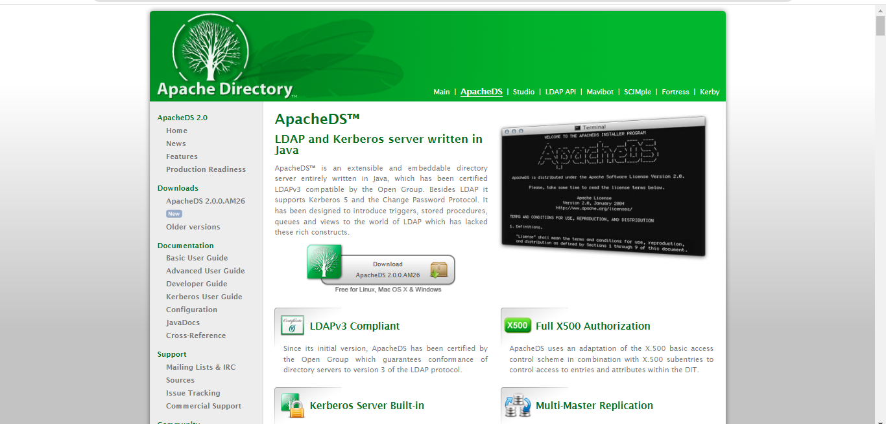

And we have to download the Apache DS Studio and then we need to have Java version to open this studio

Now we can open the Apache DS - 2.0.0.AM26 zip file and click on the Bat file to start LDAP server

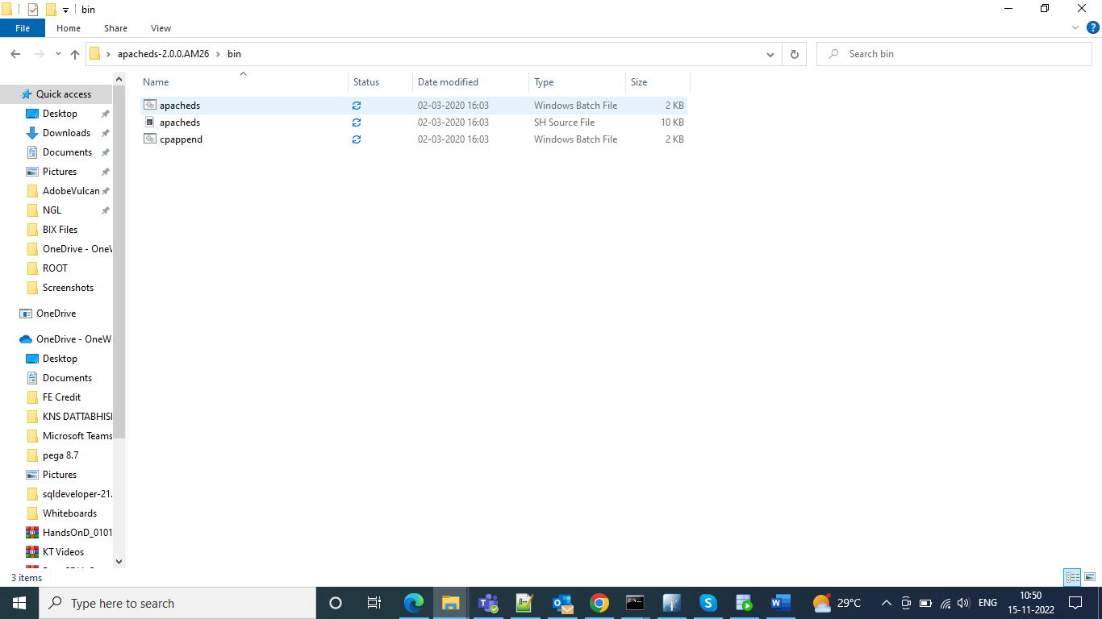

and then we can run the bat and we can see successful installation

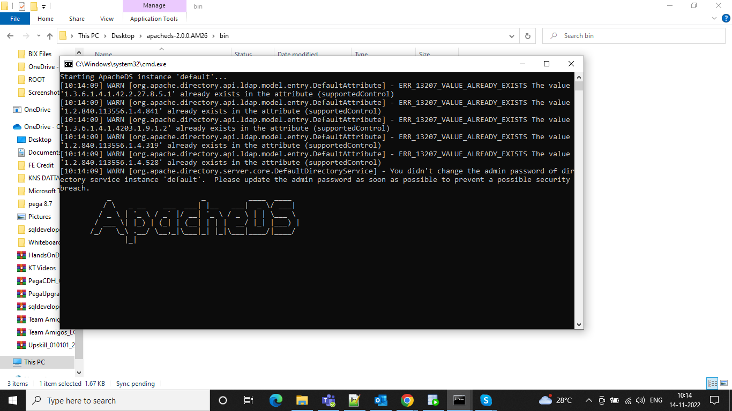

And after this we will have to add our environment variables from dvanced configuration settings in This PC and properties

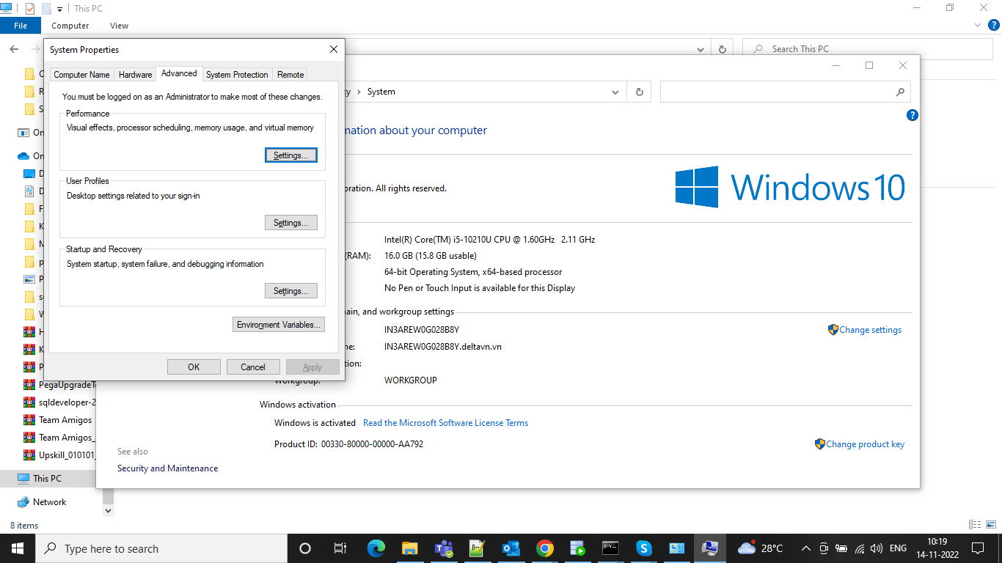and update the variables

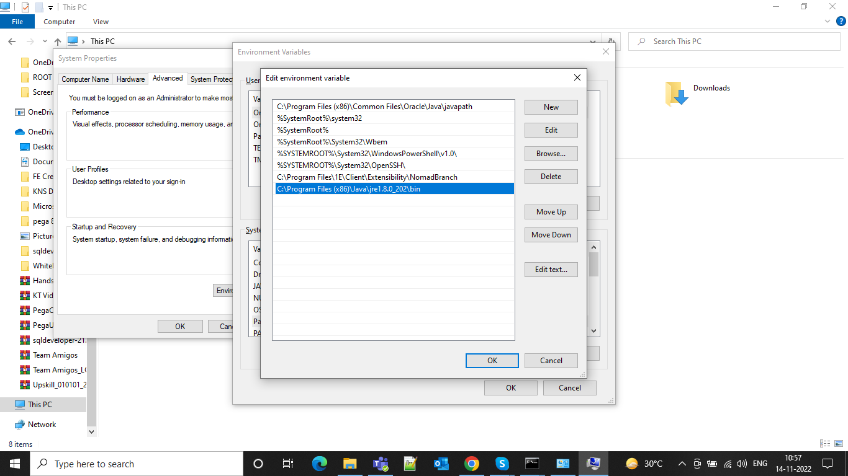

And after that we can check in javac is there or not in the java bin

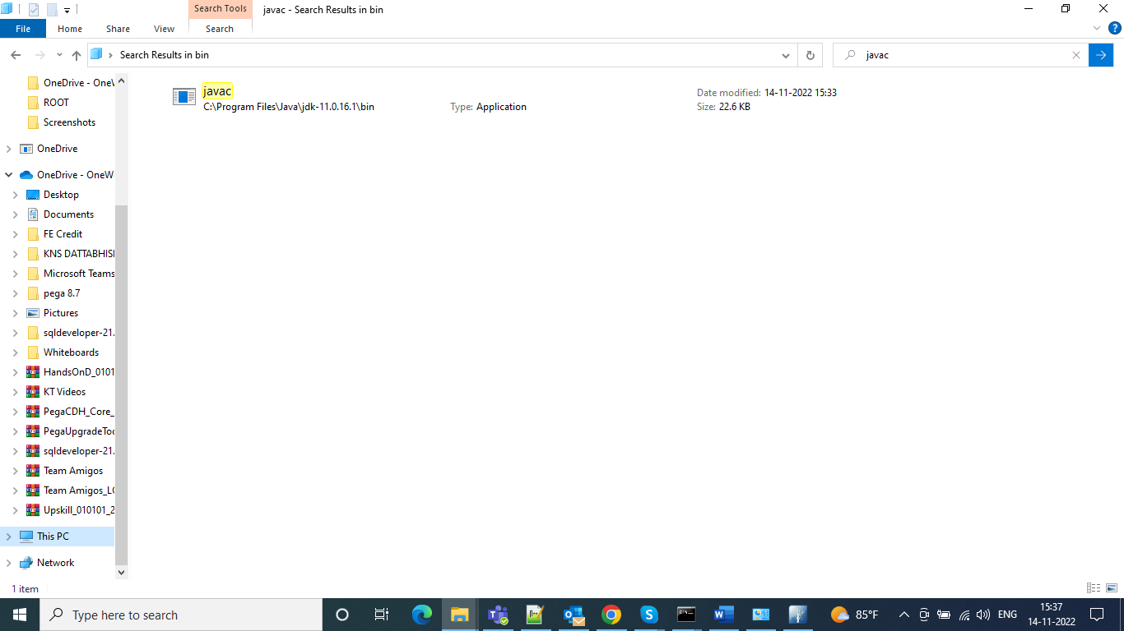

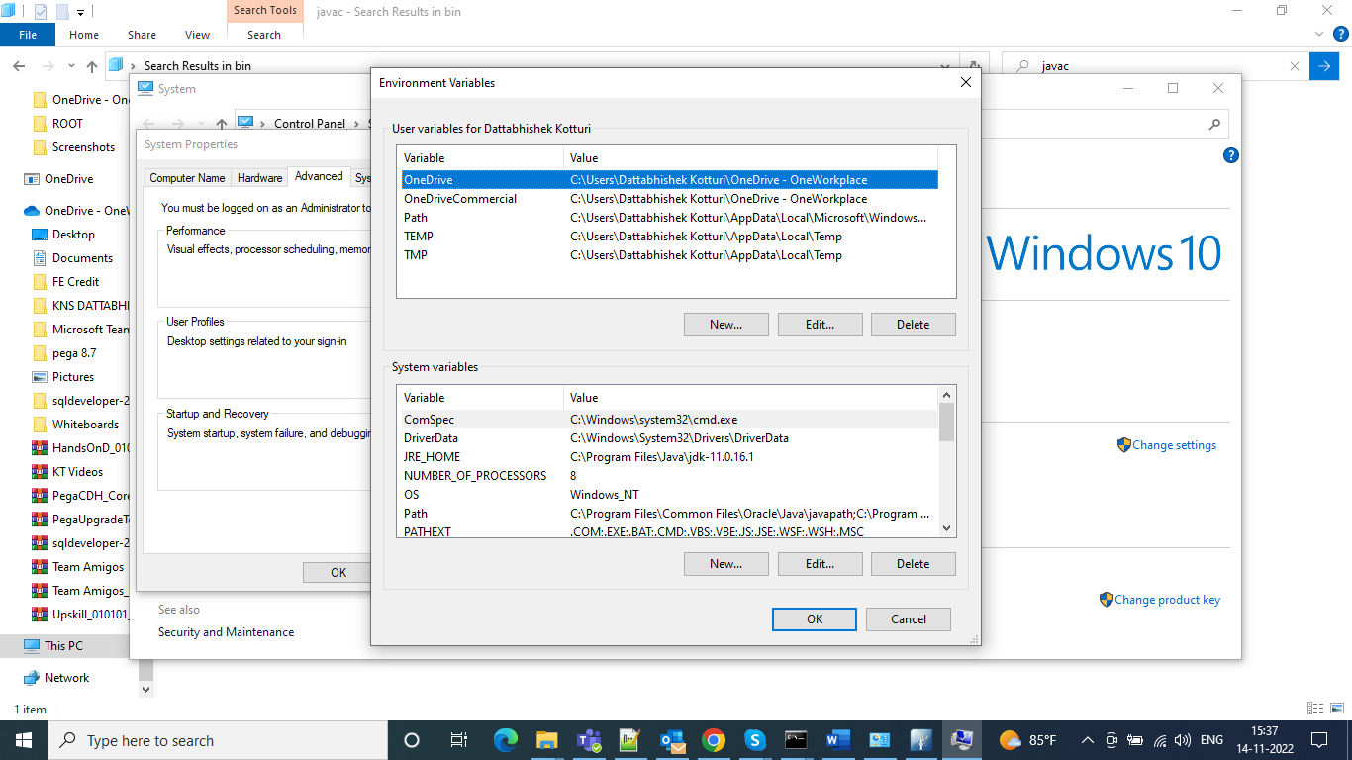

And after that open the directory studio and we can see the launch of the studio

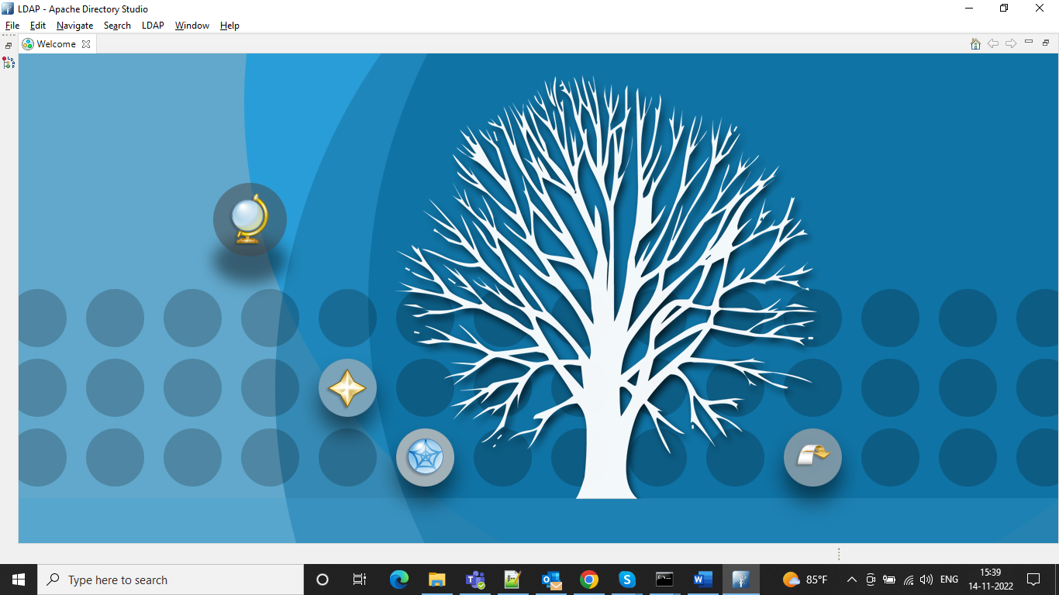

And after that we will see an interface like this and then we can right click and start new connection

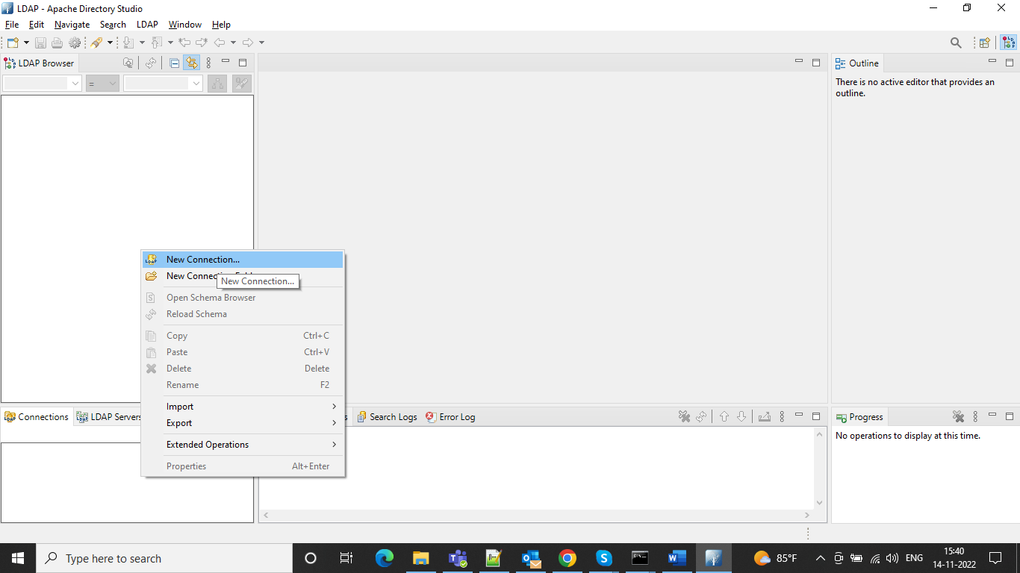

And we can give the connection name and localhost and port as 10389 which is default port for the LDAP browser and click next

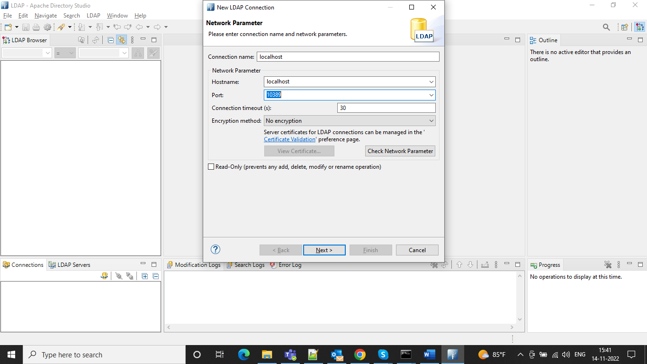

And now provide the user id and password as mentioned below and the password as “secret” and click check authentication.

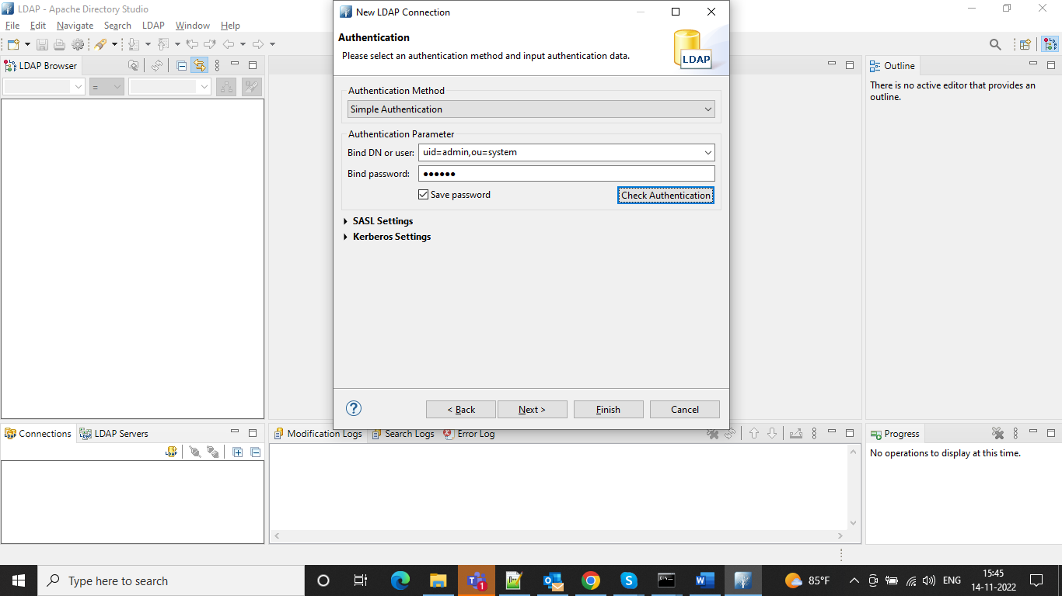

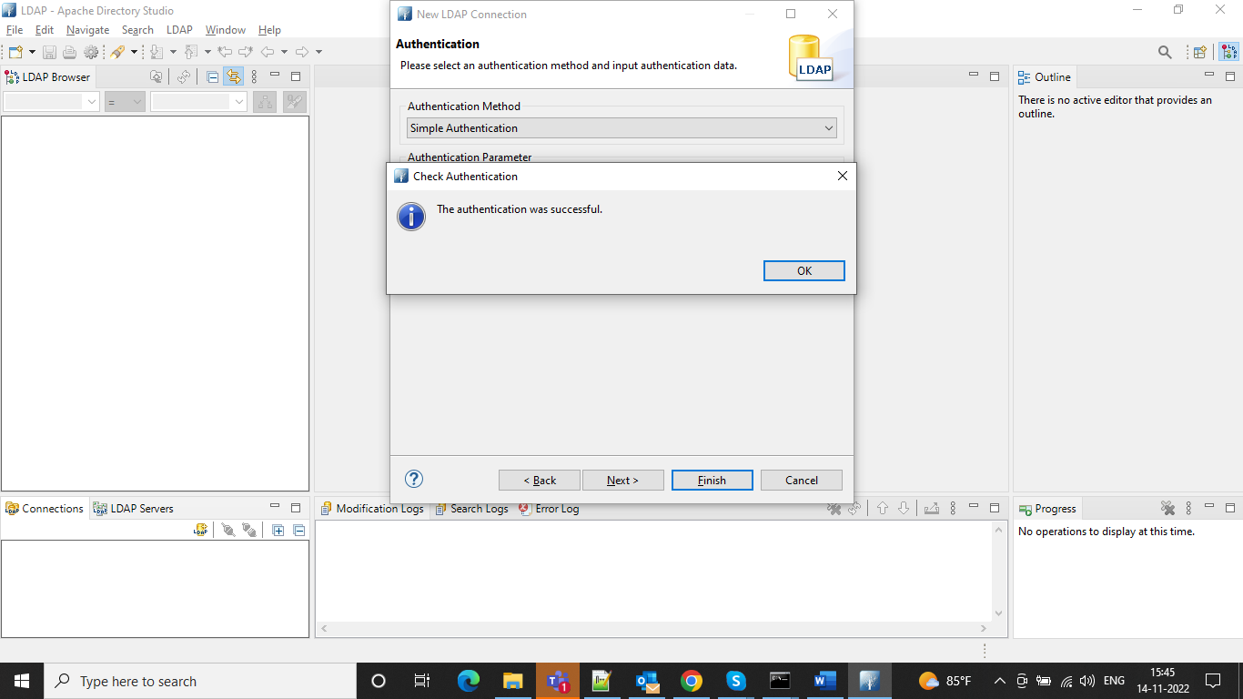

Once connection is successful we can see the admin profile on the left and now we can create one new entry for the operator and search for the inetOrgPerson and double click and then click next

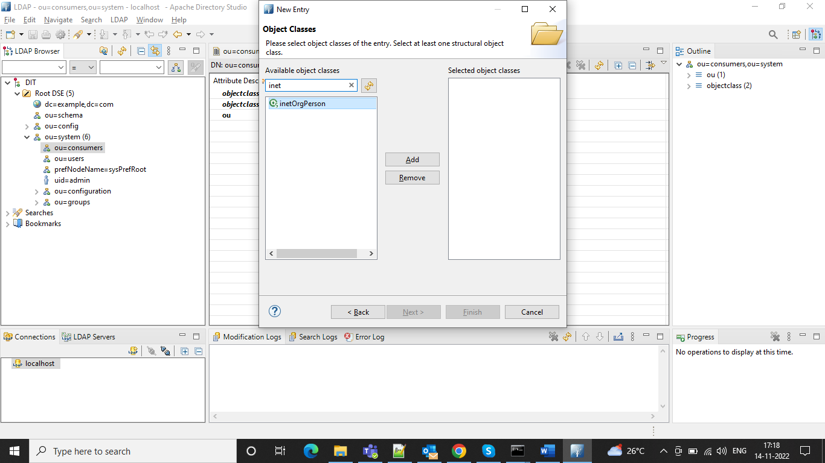

‘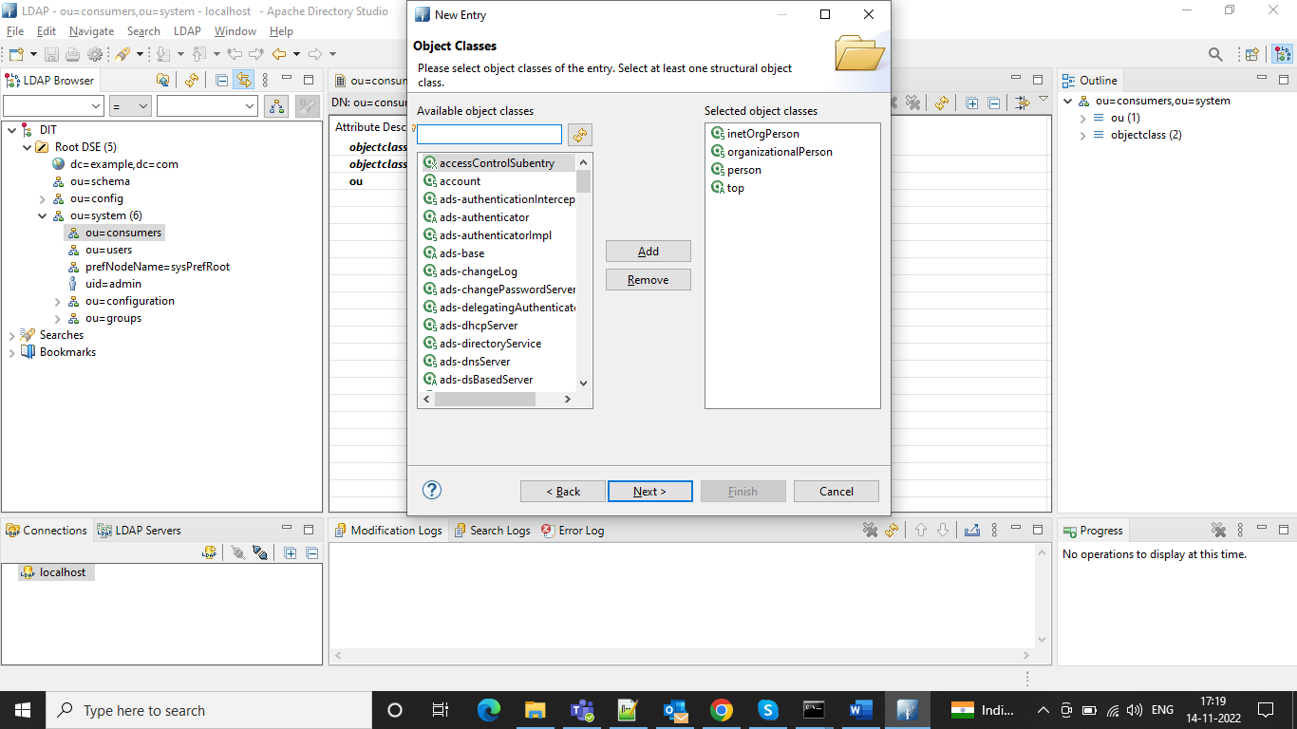

And in the distinguished name we can provide the unit as consumer and it is present in the system

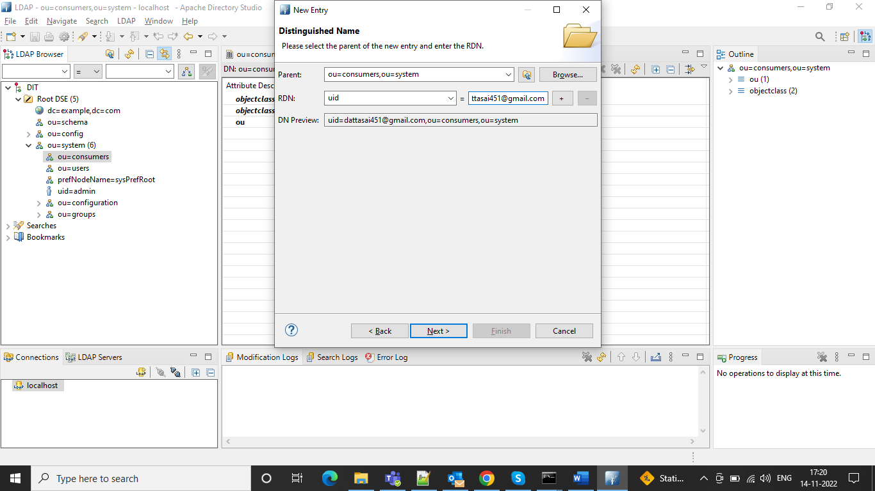

And in the user id we can give our name and click Next and now we need to add attributes

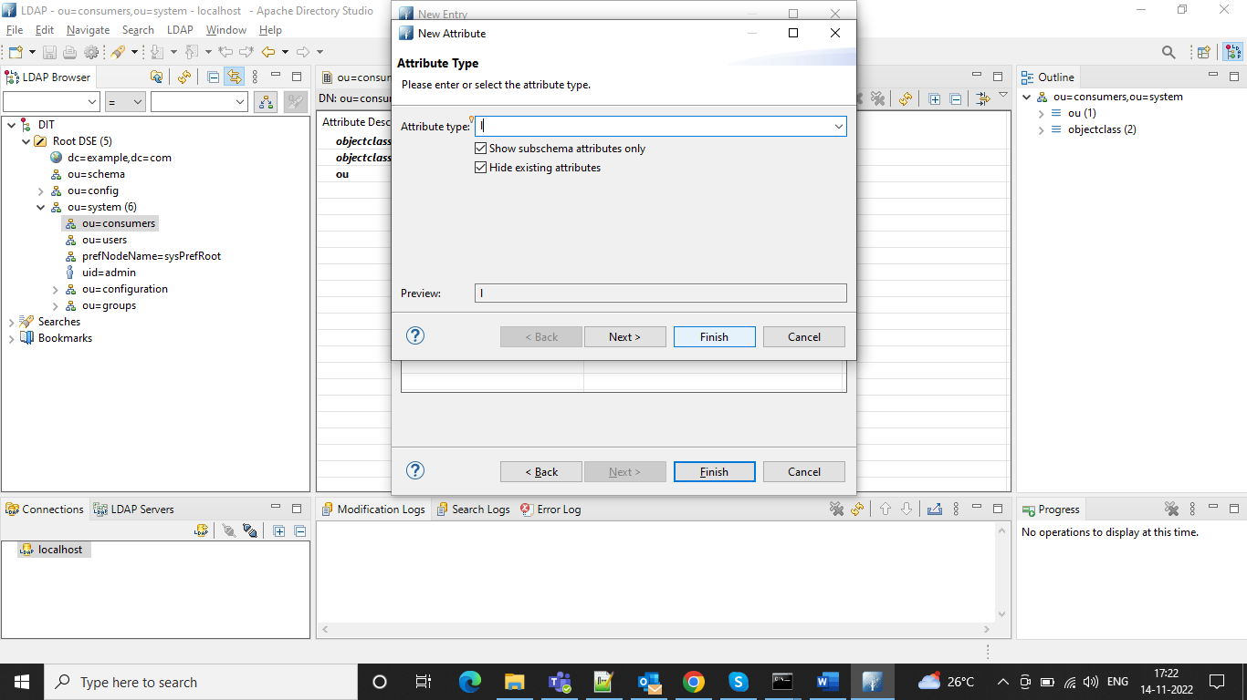

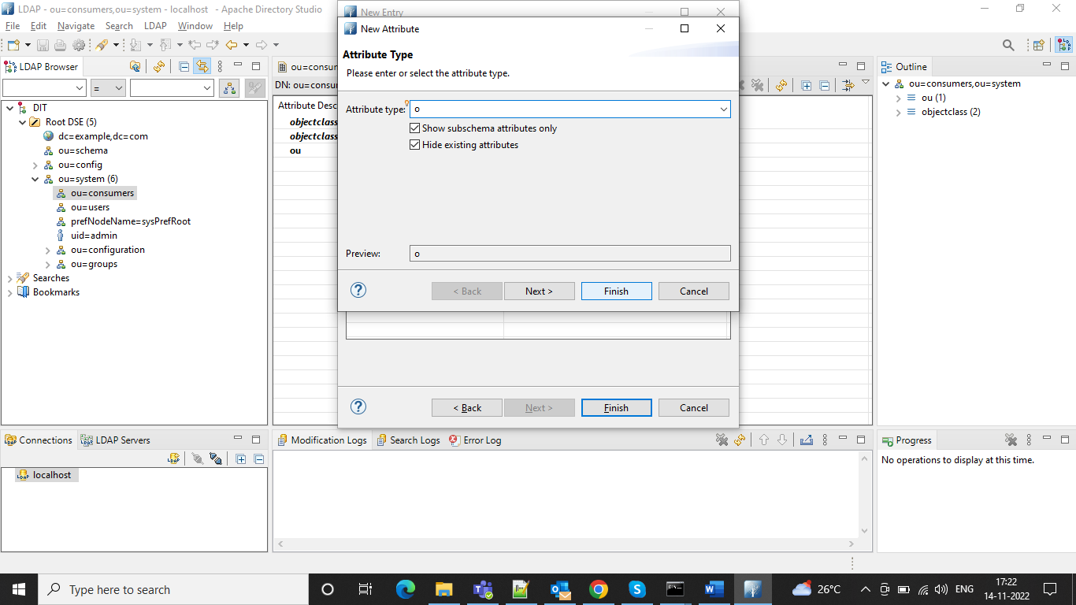

And we need to search for User Password

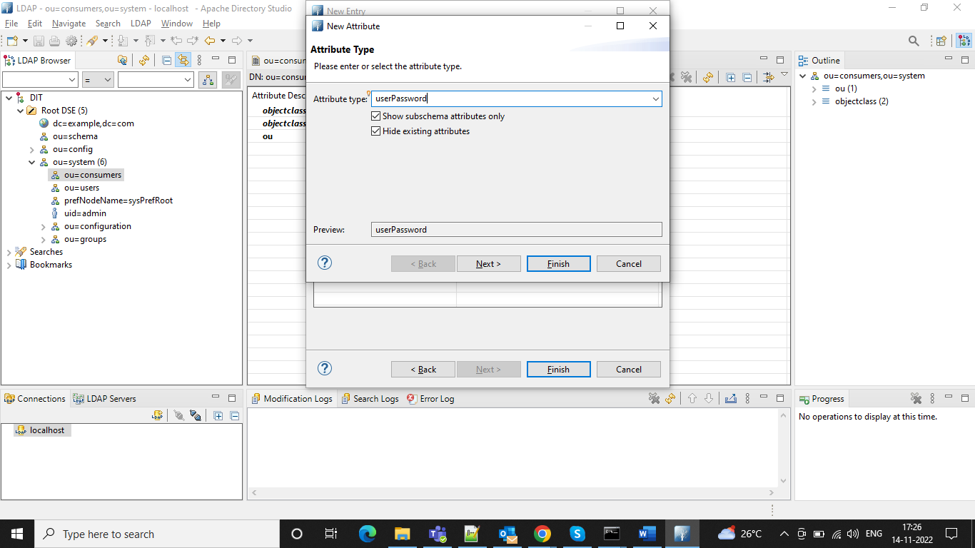

And we can give a new password and after that we can confirm as the new password and all our attributes would be added

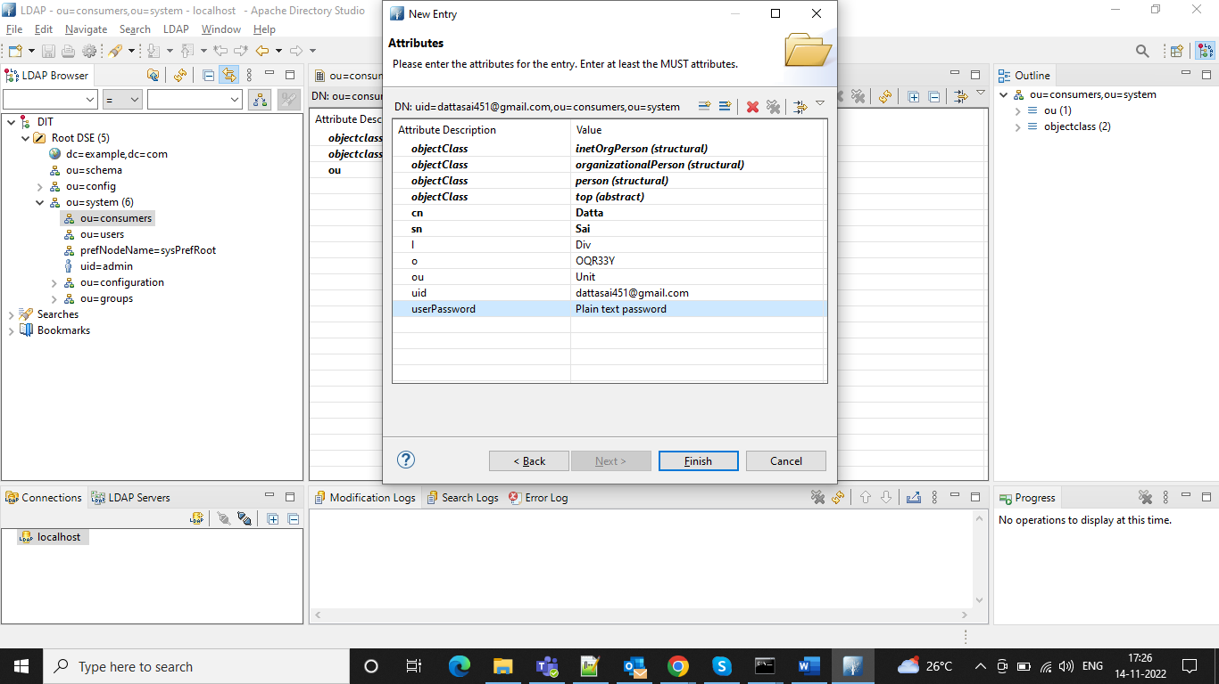

And once we finish our operator would be generated and then we can get the results in our console

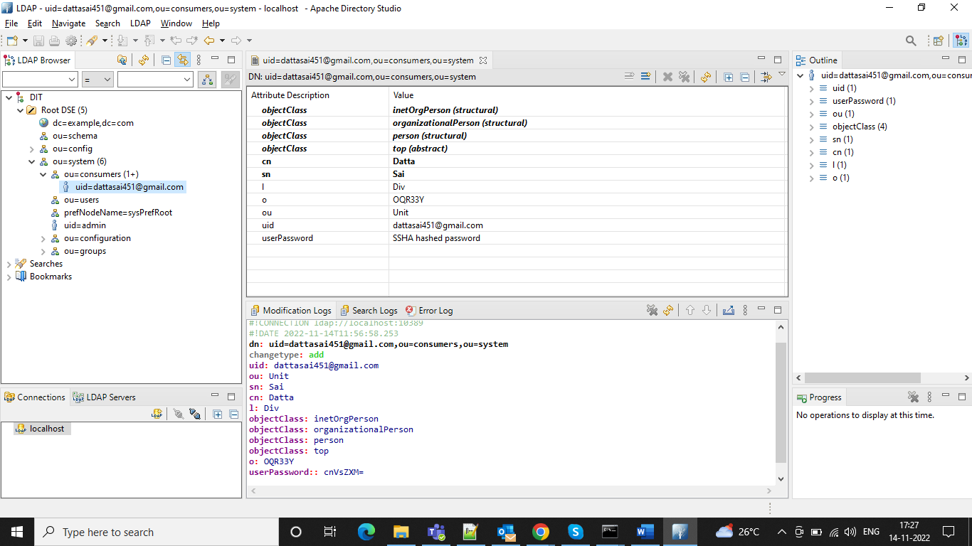

And the admin operator is used to create connection between the LDAP and Pega Server and then we can go to our dev studio

Under the sysadmin Authentication Service

And use as the authentication type as the Custom and in the dropdown can select as the WebLDAP1/ WebLDAP2/ WebLDAP3

And short description automatically populates

And in the login configuration can use as the custom authentication activity and timeout activity as below

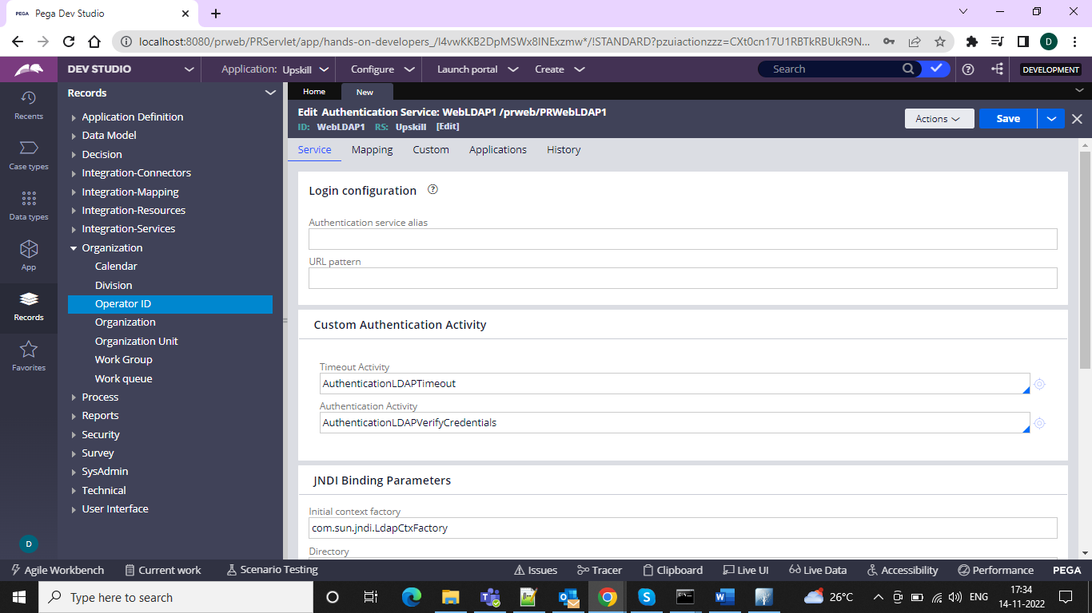

And in the binding parameters can give as below and test the connectivity and give the attribute parameters and the mapping and in the attribute as the shown below

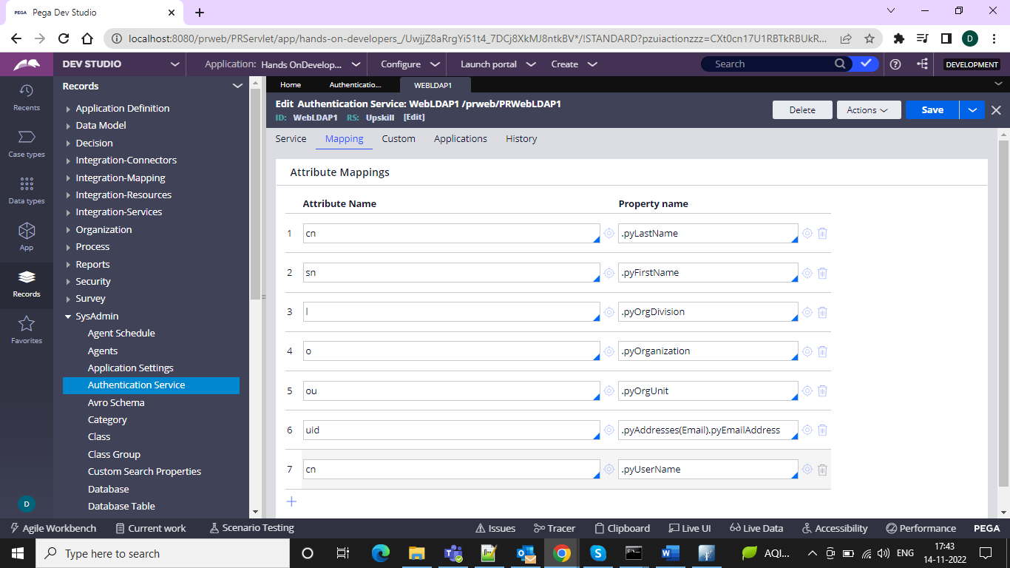

And we need to create one model operator LDAPModelUser and give our organization Division and Unit and give as the users and in the security tab select use external authentication and when we launch the browser and the URL would be as



prweb/LDAP1